**Mobile Application Features**

Hands on experience on Erudex learning application are mostly concentrated on mobile platform rather than systems by our students. This document is about the graphical differences in mobile platform.

1. **Home Page**

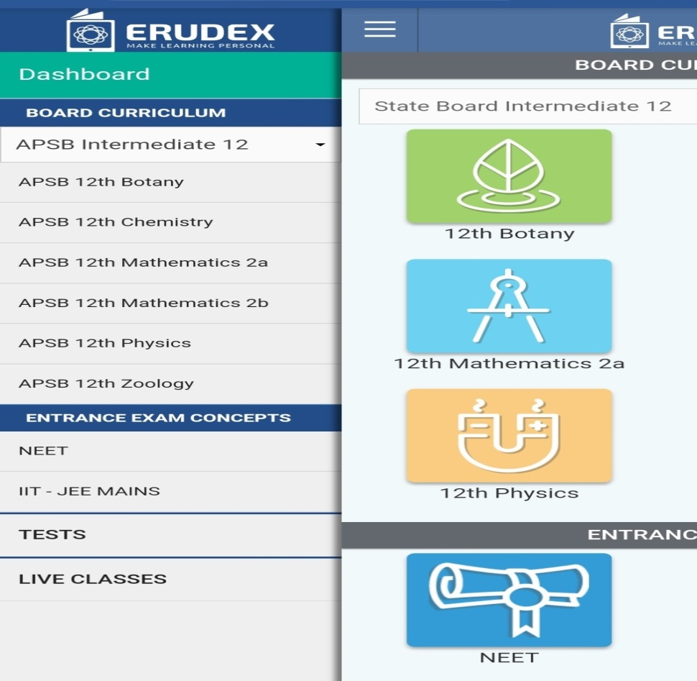

* Home page of Erudex application, Mobile view is very different compared to system view.
* Contents like Board Curriculum, Entrance exam concepts, Tests, and Live classes are displayed.
* Assignments and self-assessments are displayed directly under each and every topic wise for all the subjects.
* Reports of the students are shown in the tests column for particular test.
* This helps the students to understand the application very fast and gets easy and fast hands on experience.

1. **Dashboard**

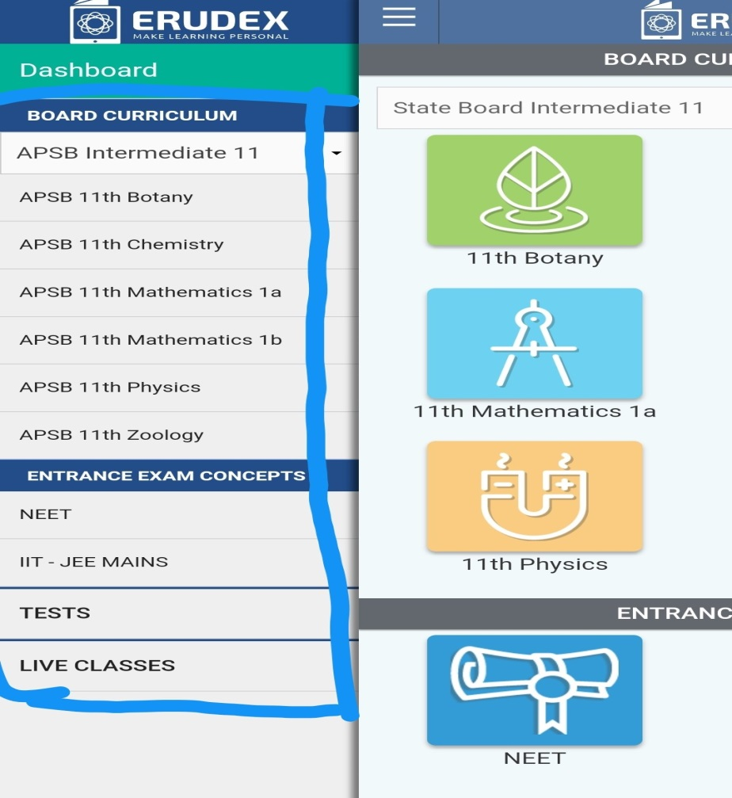

* Contents displayed in the mobile applications are different compared to the system application.
* Board Curriculum, Entrance exam concepts, Tests, and Live classes are displayed in the dashboard.
* All the updates for all subjects, tests and live classes are directly updated from the teacher.
* Students can go through the information listed by their teacher by clicking on subjects, tests or live classes.

1. **Subjects Graphical Representation**

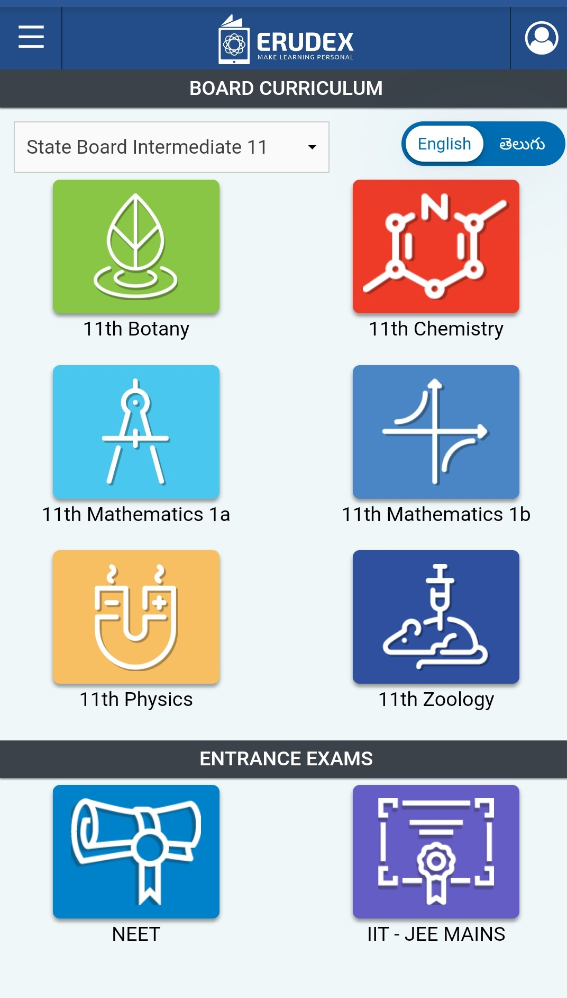

* Representations are very peculiar and very understandable according to the subjects.
* Unique feature available for our application which displays their scientific notations of labels for each and every subject.
* Compared to the system view curriculum page is displayed with all the subjects with scientific representations in the systematic order.
* In system applications subjects are displayed with normal nomenclature on the top of the page.

1. **Test Practice Exams**

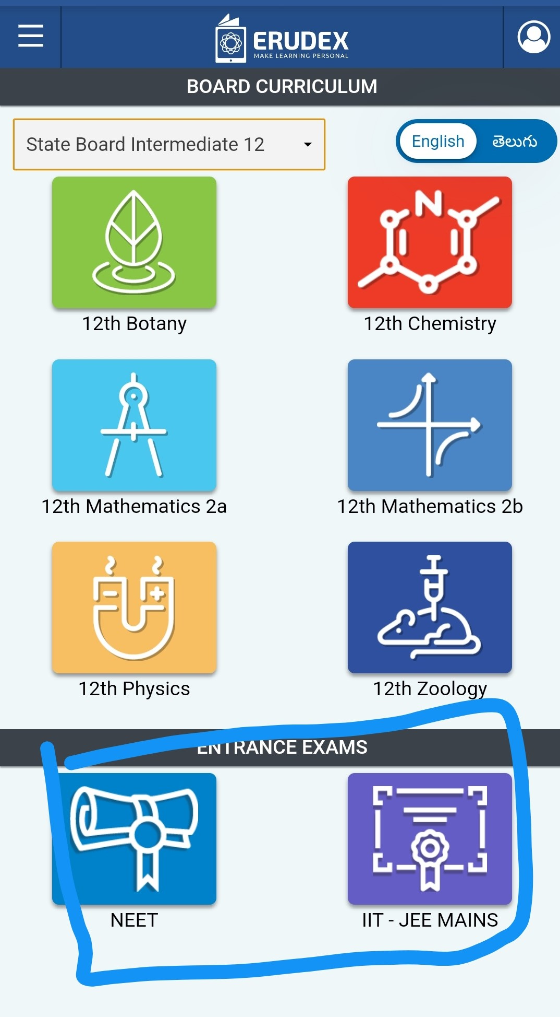

* Test practice exams for NEET and JEE in mobile application are displayed right below the subjects of the grade.
* In system application test practice exams are displayed in different column which enlights the difference between them.
* Practice test for NEET & MAINS are directly accessed in the same curriculum page which is very effective and time efficient for our students.
* Practice Tests will be assigned by our teachers in NEET and MAINS for our students which will be very helpful for our students to cope up with their subject knowledge.

1. **Representation of Test Questions**

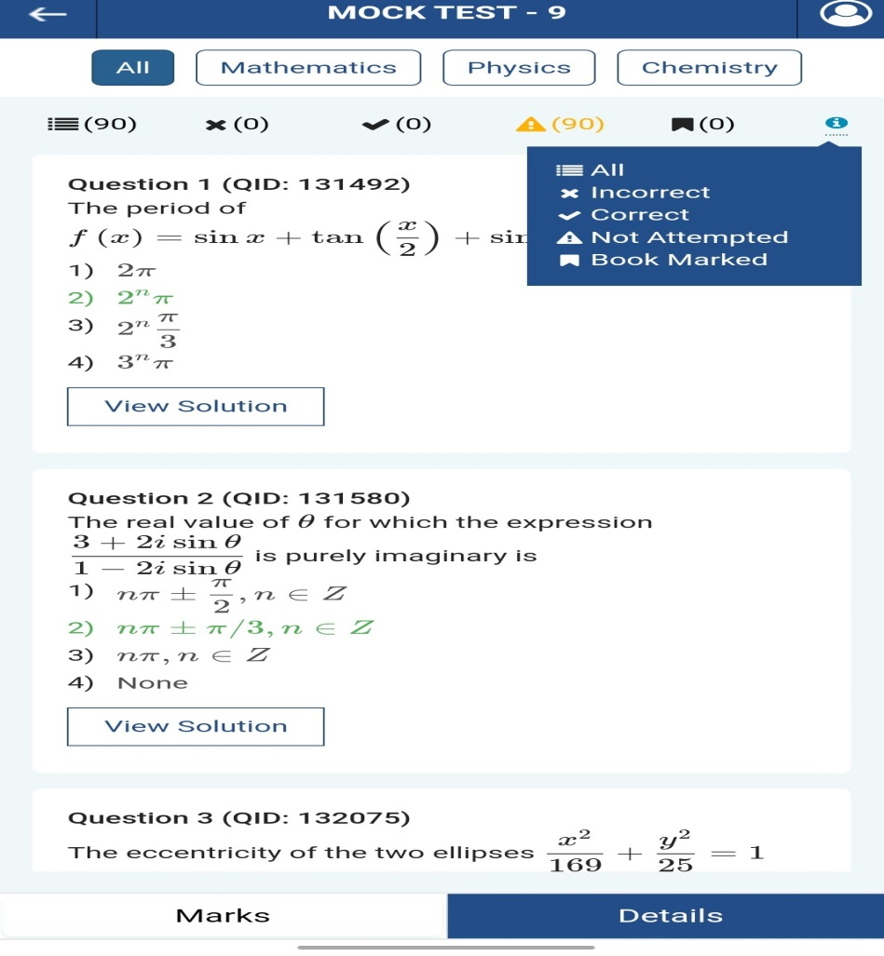

* Notations of the tests are different where compared with both the applications.
* While attending the tests students can choose subject for which he wants to attend firstly.
* In mobile view notations of answered questions are displayed with relevant symbols and what they represent.
* In system view application notations of answered questions are displayed with relevant names on the top.
* Symbols and their representations are also listed on the top right corner of the page which is completely a different feature available for mobile application users.

1. **Practice Test of all Grades**

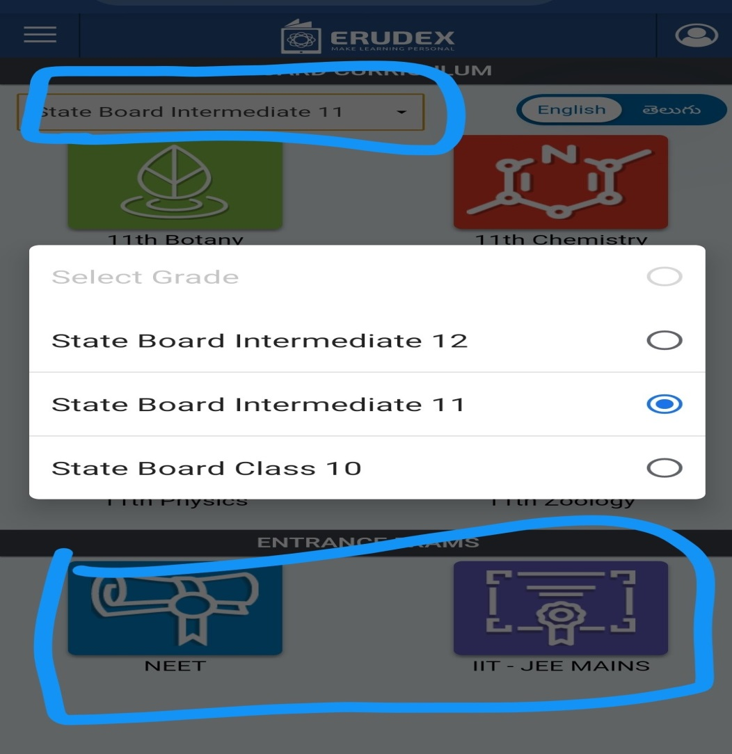

* Board change options are displayed with the dropdown on the curriculum page directly.
* Grade change can be selected by the students directly from the options.
* According with the board change as well as the sample test exams for NEET & MAINS for specific grades are also displayed.
* In system application test practice exams are displayed in different column which helps our students to search them and takes a second compared to the mobile application.
* In mobile application test practice exams are displayed rights under the fingers of our students.

1. **Reports**

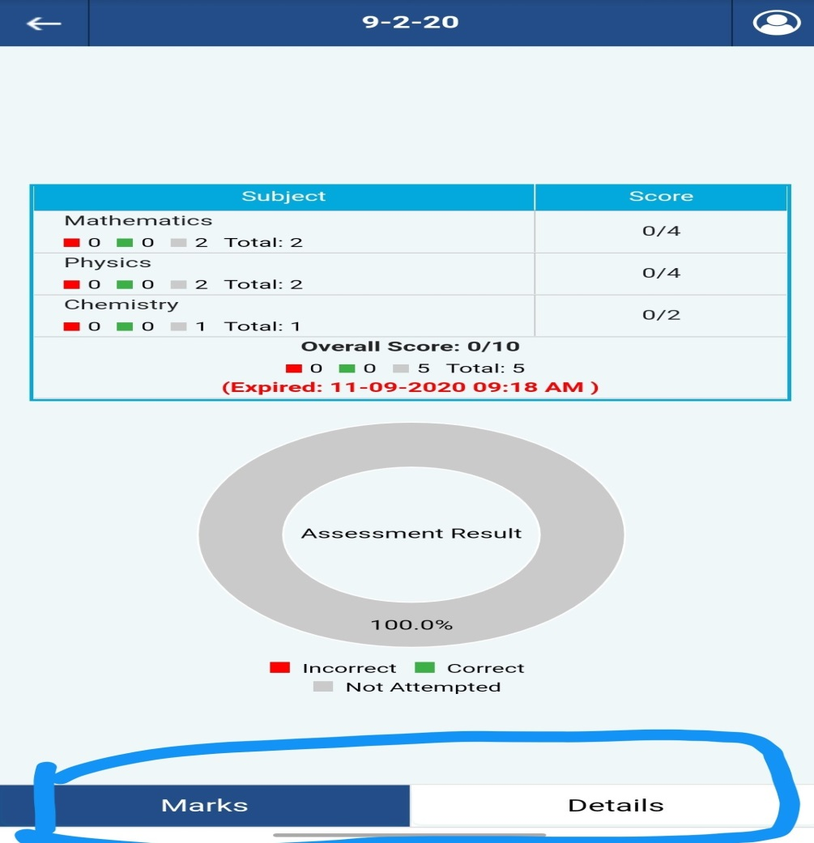

* In system application the reports of students are displayed in reports and performance columns.
* When comes to mobile applications report of each test and marks of each tests are displayed with two buttons side by side Marks & Details.
* Clicking on marks we can view the assessment result which displays total questions and overall score calculated by correct and incorrect questions.
* Details button will display the questions which are attempted and not attempted with proper result.
* Results are displayed by Correct, Incorrect, Not attempted, Bookmarked, and All questions.

1. **Live Classes**

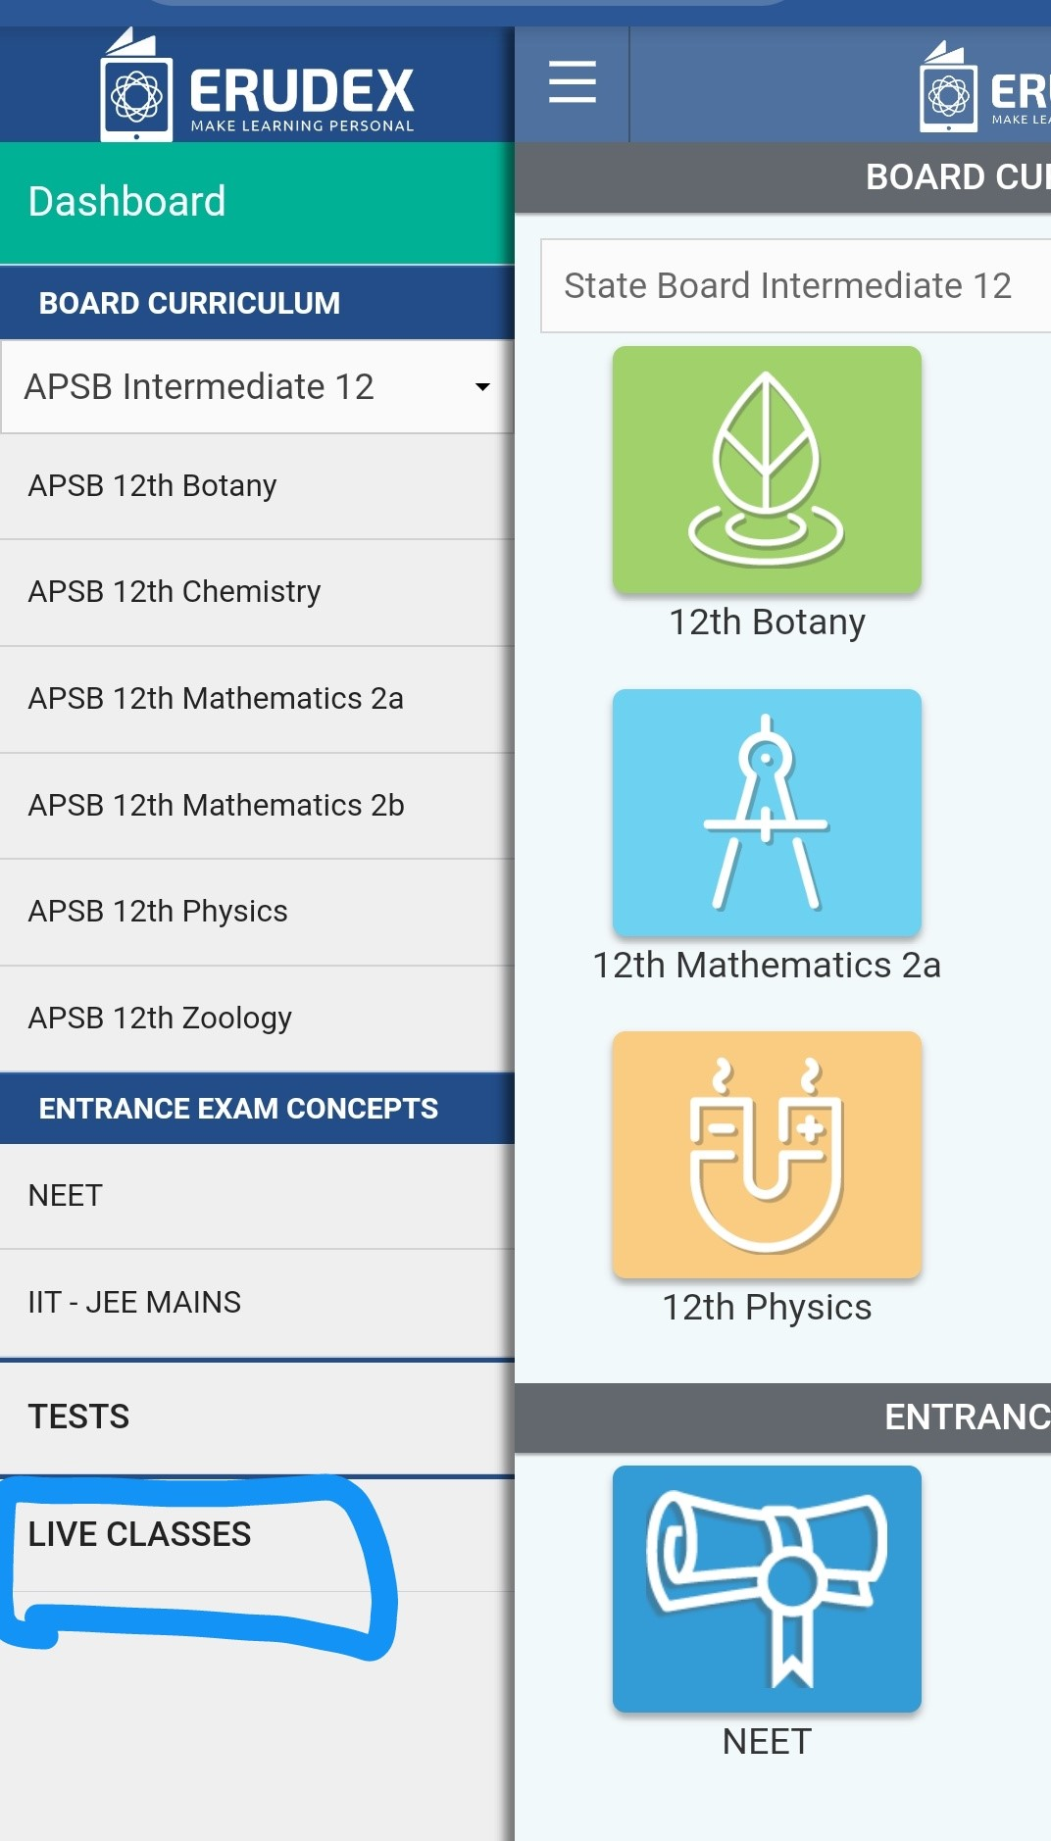 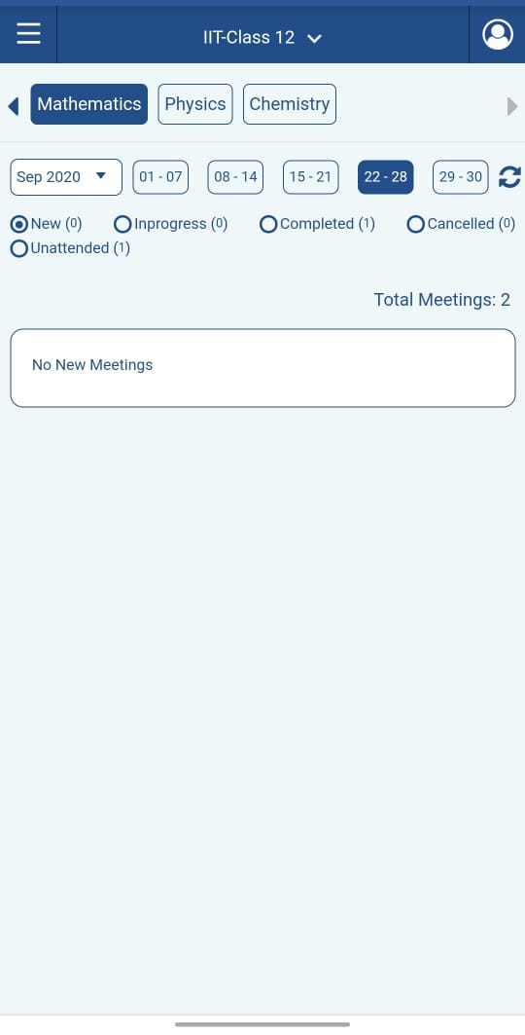

* This represents the live class tab in the mobile applications, views are same compared to the system application.
* Subject wise live class information is displayed.
* Scheduled meetings are displayed in New, ongoing meetings are listed in Inprogress likewise completed and cancelled meetings are also listed for students information
* Live classes displays subject wise on going live streaming for ongoing and every week.
* In the above screenshot displays the live ongoing meetings and details of all the overall meetings held for our students.

1. **Settings & Pwd change**

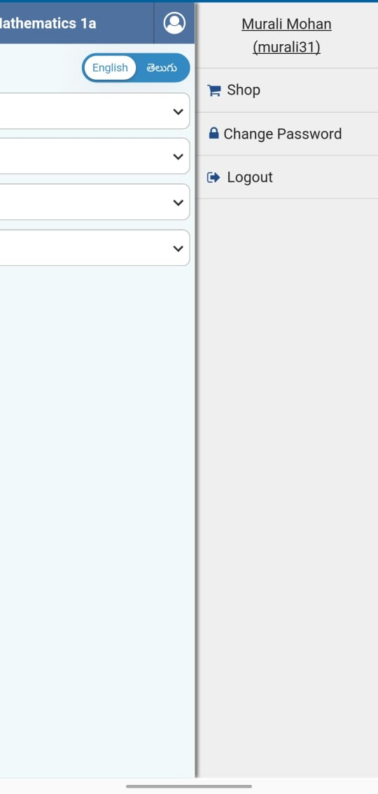

* Settings option is different where compared to both the applications.
* This displays Shop, Change Password, and Logout.
* EAMCET, JEE-MAINS, NEET courses are available for purchase in shop.
* In system applications settings for password change in displayed on the left bottom of the scroll page.
* In mobile applications settings for password change in displayed on the bottom of the user icon which is very flexible.
* Courses can also be purchased from the shop displayed on the top of the user icon.

1. **Assignments & Assessments**

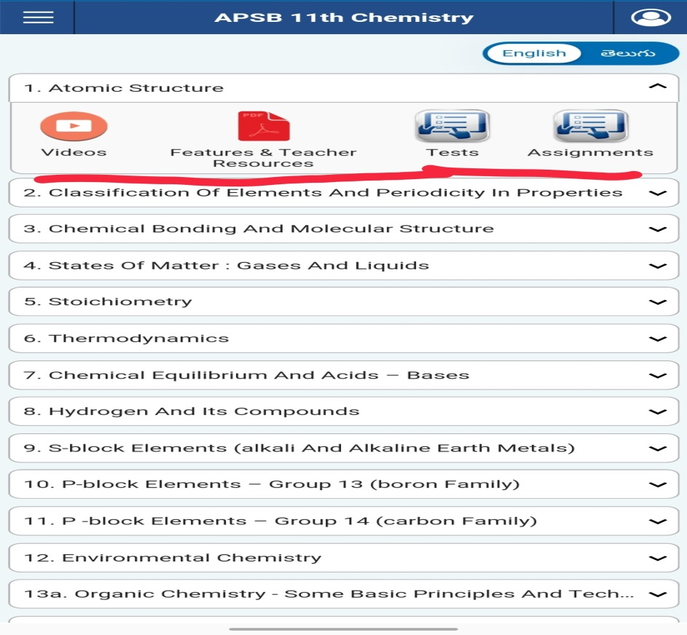

* In system applications we find separate columns for self-assessments and assignments.
* In mobile application assignments and self-assessments are displayed under every subject and for every topic
* This feature helps students to test their skills and knowledge for each and every topic covered.
* For each and every topic there are videos related to the topic for better understanding teacher resources are also available for our students.
* Tests are classified under few categories like pending tests, completed tests and ongoing tests.
* Students who missed their tests on the assigned day can take their tests when they are ready to take under pending test.

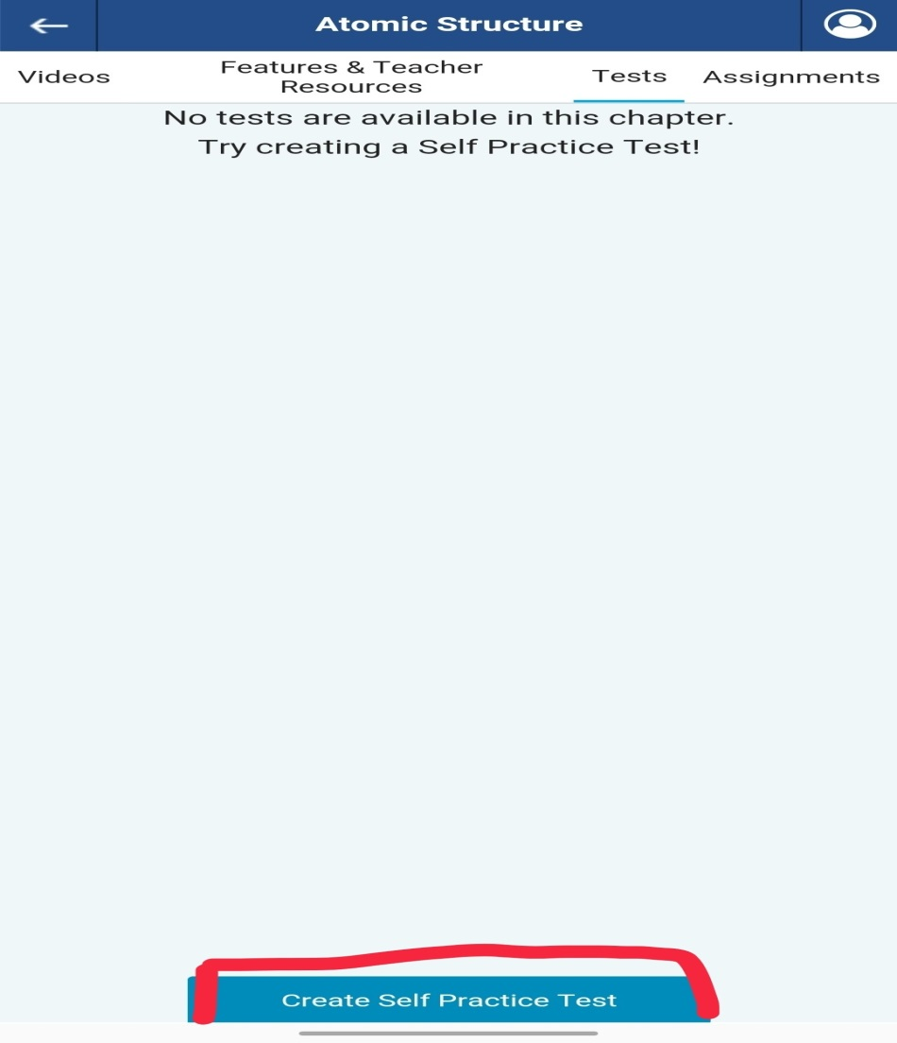

* Our Mobile Learning app is providing a beautiful feature for our students to create their own self tests for every topic.
* By clicking on Create self-practice test our students can create their own self practice test based on their understanding on the topics.
* These features are provided by only ERUDEX learning app which gives students best hands on experience on their learning platforms.

1. **Video Topics**

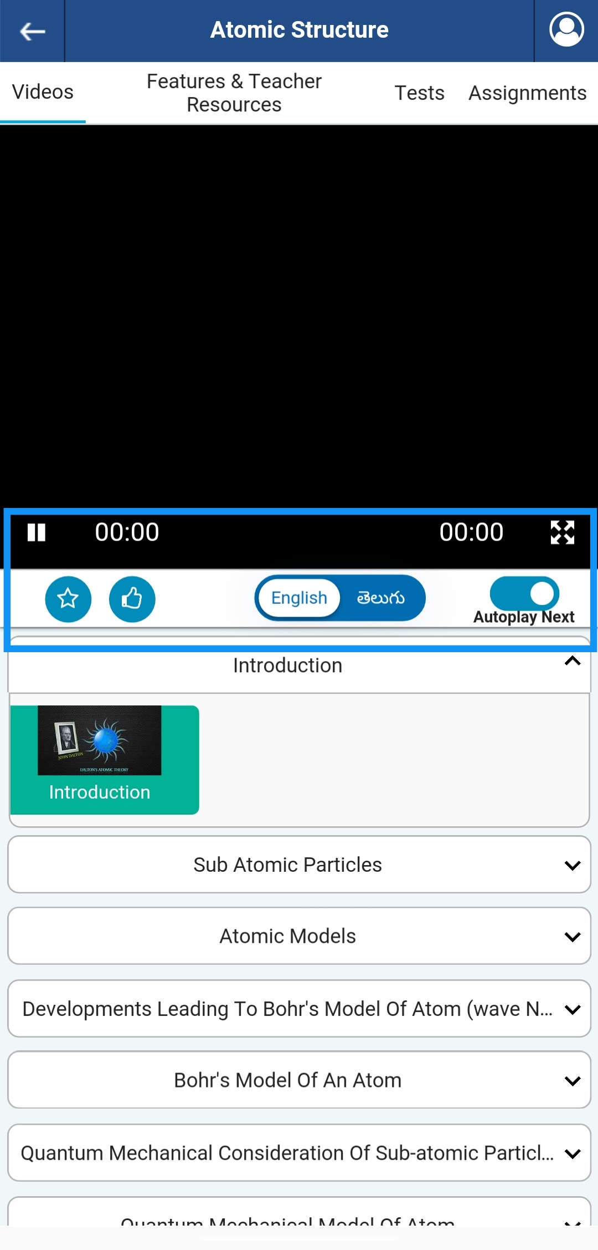

* Our learning application provides video tutorial for all the topics and syllabus covered.
* Any language medium students can access this application; we are providing a feature for language change for English/Telugu to all our students using this application.
* Students can stop the video in the middle and make notes and can continue the video.
* Autoplay option is the new feature that is provided by our application, students can switch on or off this auto play option for their convenience.
* Video rating feature is also provided, when a Topic is viewed can also be rated by the students from 1 to 5 based on the information gained.

1. **Language Selection**

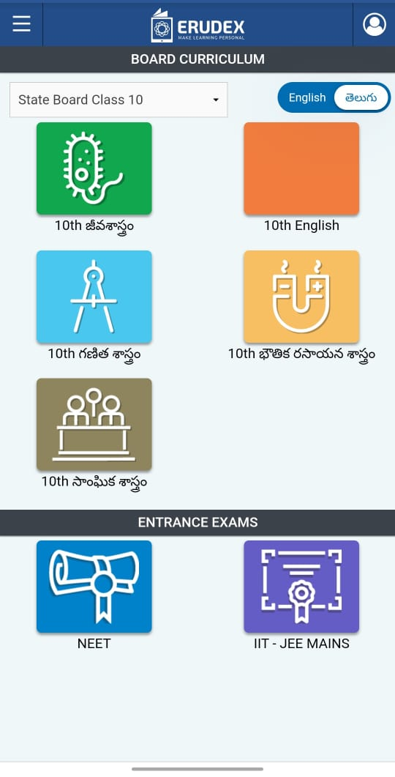

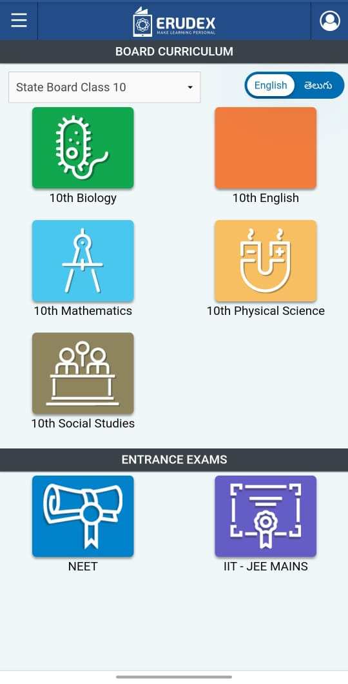

* As mentioned we are the only application providing with an important feature of language selection all the students of Andhra Pradesh and Telangana.
* Two images uploaded above shows the language mediums English and Telugu.

**Observations:**

* After I clicked on shop tab to purchase any course its redirecting and coming back to home page (Main Application).
* After being registered as 11th grade, I can still see the dropdown of grade change for 10th and 12th from curriculum page (Demo App).

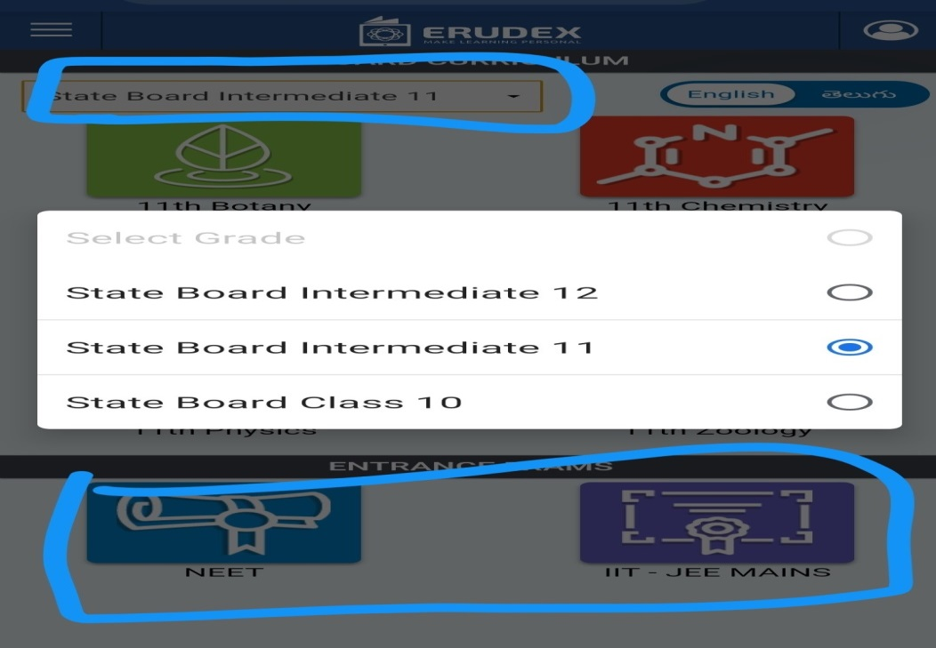

* EAMCET practice test's option is not available likewise NEET & JEE (Demo Application).

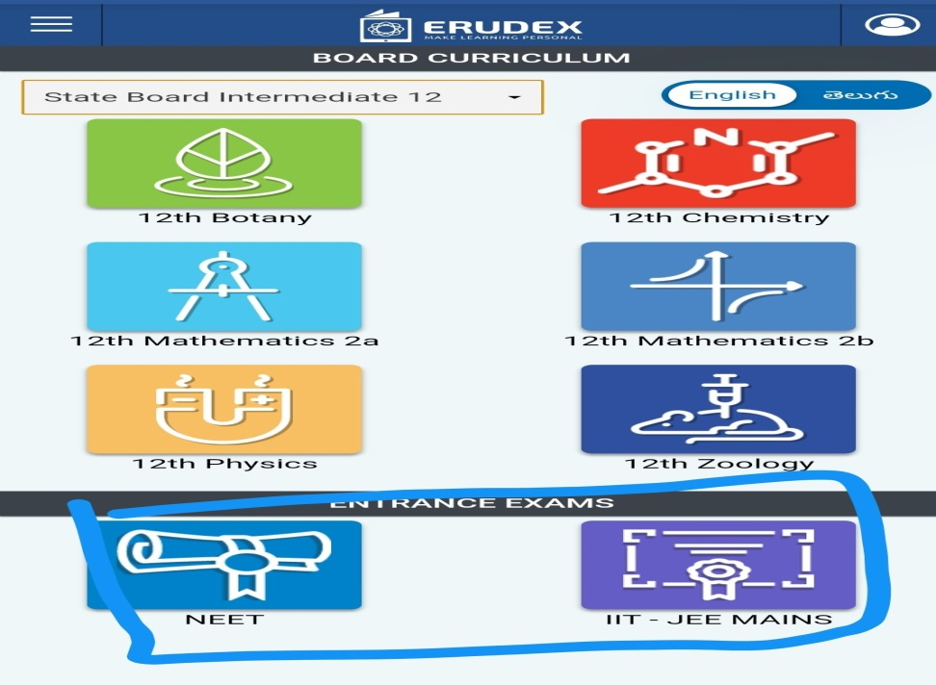

* After selecting language as Telugu in some videos content is not available in Telugu medium for 11th and 12th grades.
* Only few contents are shown/displayed in the dashboard page, Assessments, Activities, Reports, Timeline are not displayed.

